- Purpose
  - The purpose of this document is to describe the procedure for assembling the scrub deck on a propane strip machine.
- Scope
  - This SOP applies to all equipment assembly team members. The process applies to the following machine ID’s:
E012327EQM0600BE1200 – Big Bertha XSM30 Propane Stripping Machine Pkg
E088398EQM0600BE1200 – Lil Bertha XSM24 Propane Stripping Machine Pkg
- Responsibilities
  - The operations manager/supervisor is responsible for enforcing this SOP.
- Materials
  - The proper materials needed for this process are listed on the machine work order.
- Definitions
  - BB – Big Bertha
LB – Lil Bertha
- Procedure
  - Begin by placing the machine onto the pallet (E12697). Center is a best as possible. For a BB, place a piece of plywood under the rear wheels to prevent them from breaking through the skid.

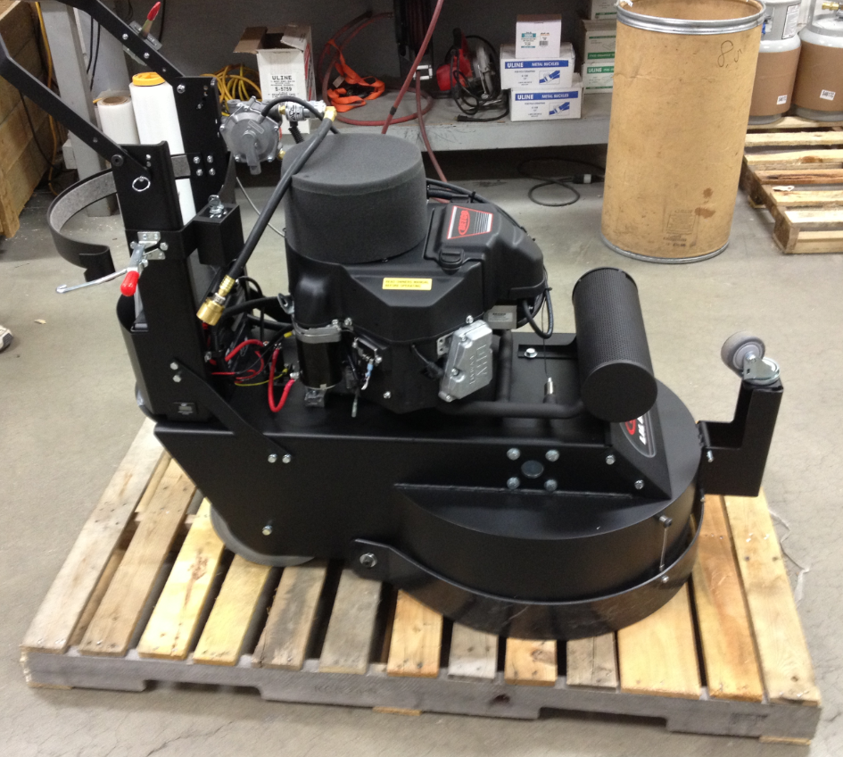

  - Fasten 2 2x4’s around each of the rear wheels as shown.

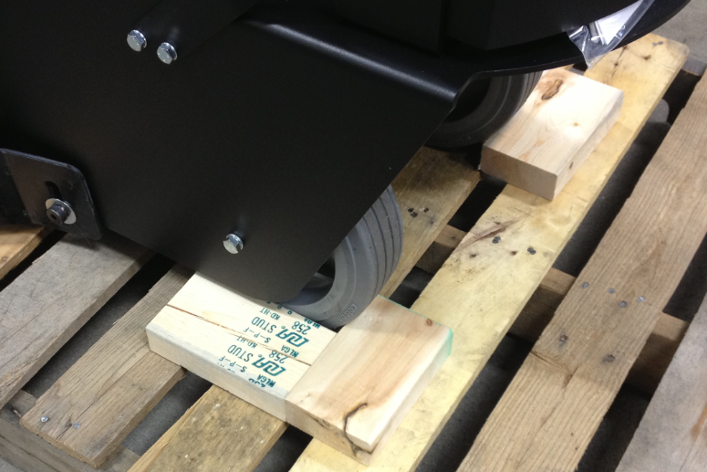
  - Fasten a 2x4 on the front of the deck as shown.

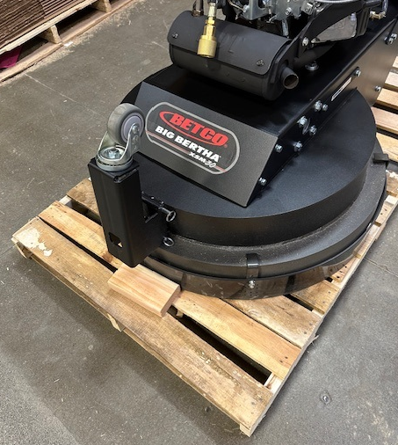

  - Take a propane tank (88550) and place a yellow label (11663) in the location shown.

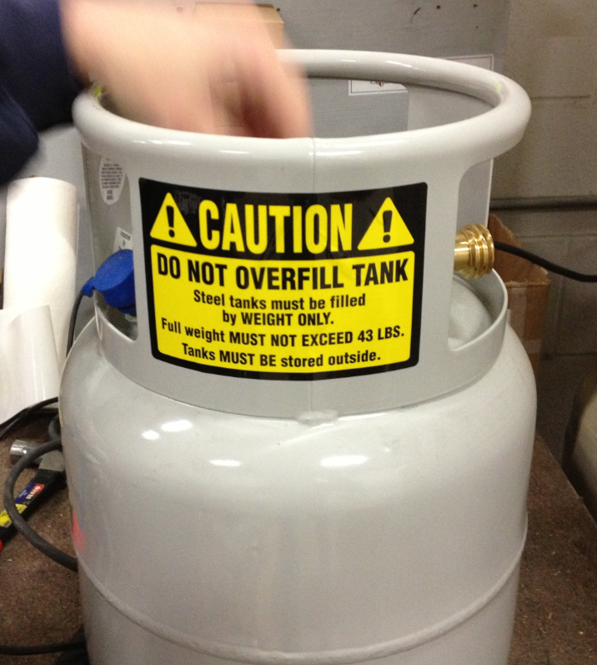

  - Remove the pins from the handle and rotate it to the transport position as shown. Replace the pins into the locations shown to secure the handle.

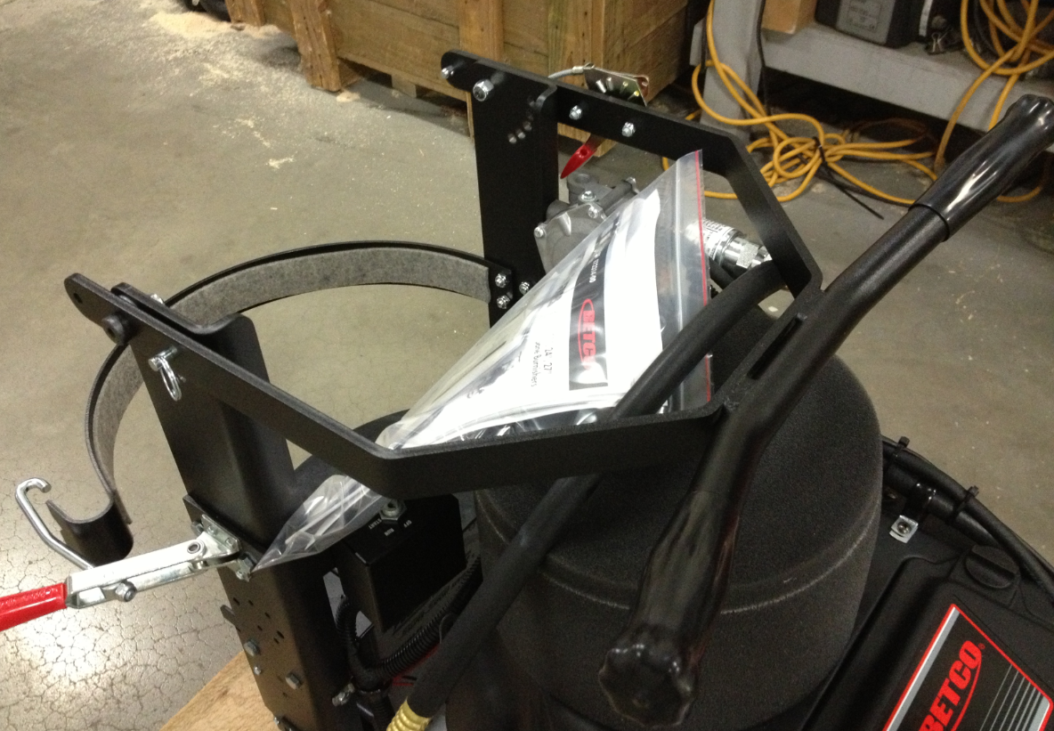

  - Plane the propane tank onto the machine, strap it in place, and connect the fuel hose from the machine.

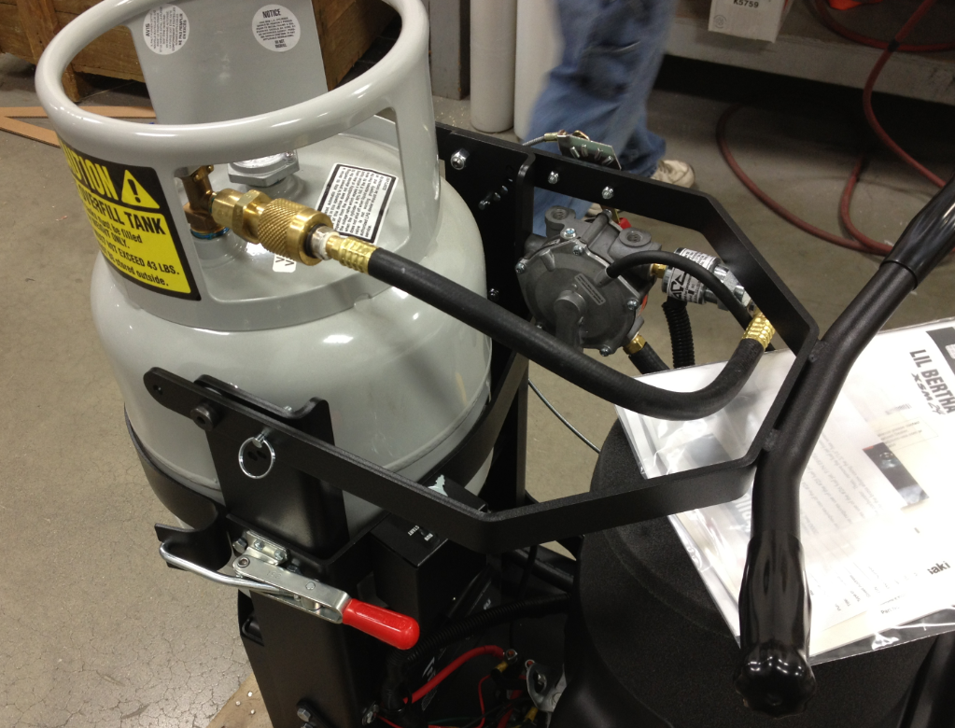

  - Place the manual packet into the top of the tank as shown. This includes a manual, a warranty registration card, a tech service business card, and a Kawasaki engine manual (if available). Removed the keys from the ignition switch and place them into the packet as well.

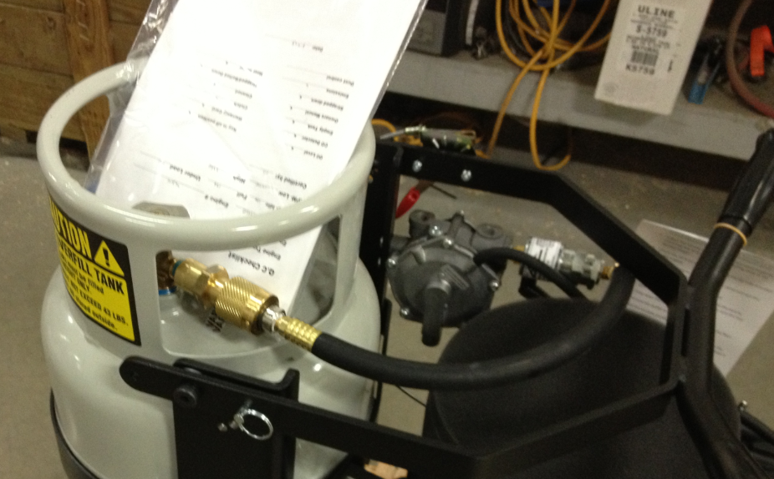

  - Place 2 metal bands over the machine in the locations shown. Use cardboard pieces on the deck anywhere that the band will touch it.

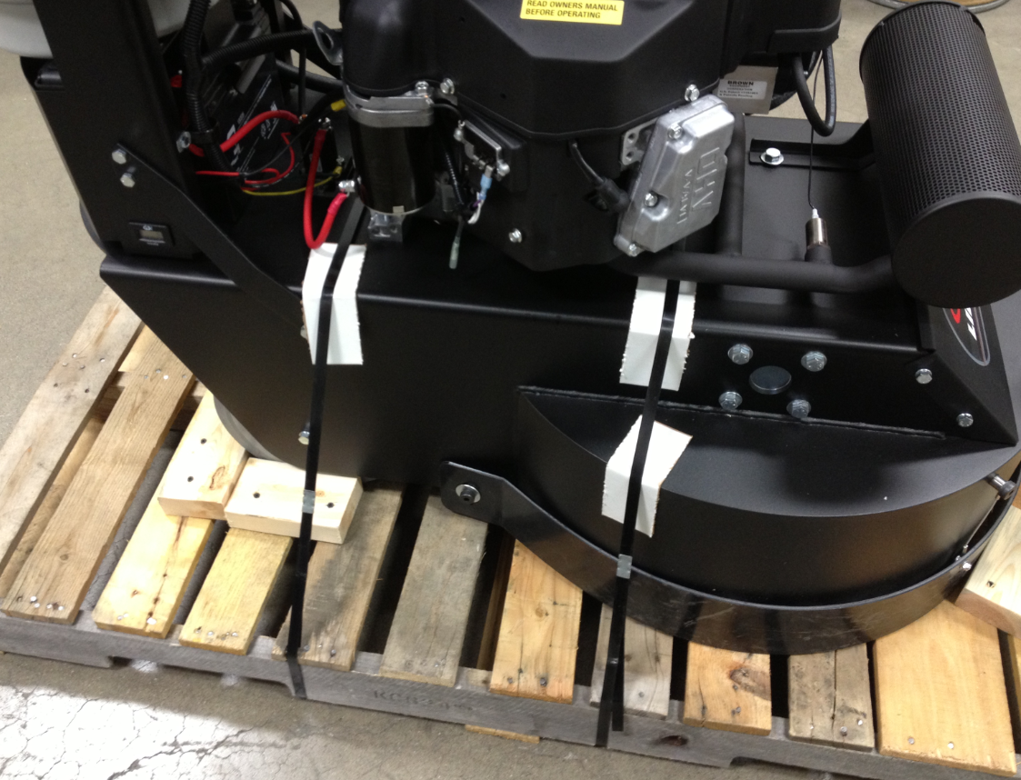

  - Assemble a shipping box (12664) and place it over the machine. Verify that the edges of the box fit over the sides of the pallet.

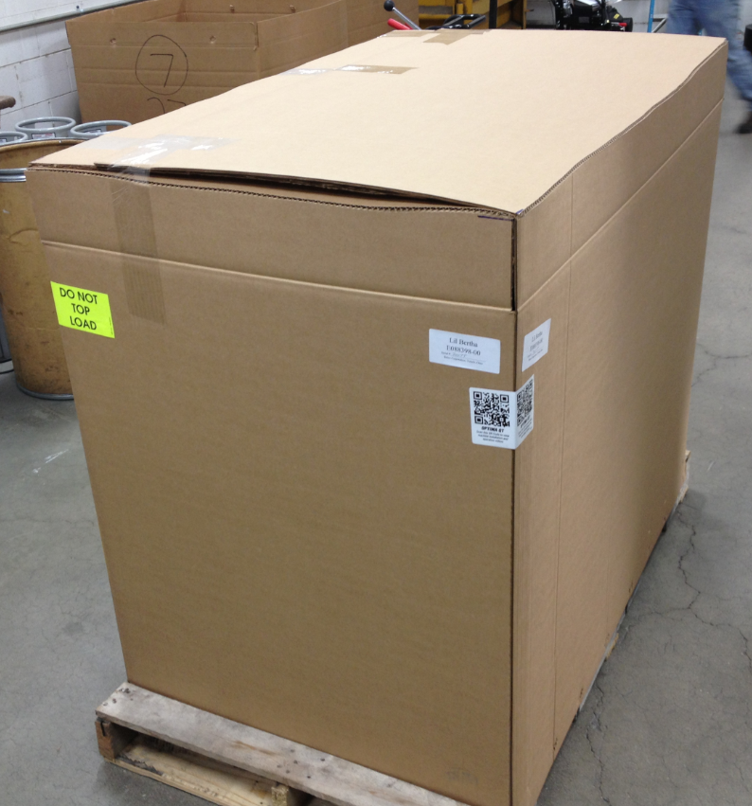

  - Staple the box to the pallet.
  - Place the machine ID and serial number barcode decal on 2 corners of the machine.

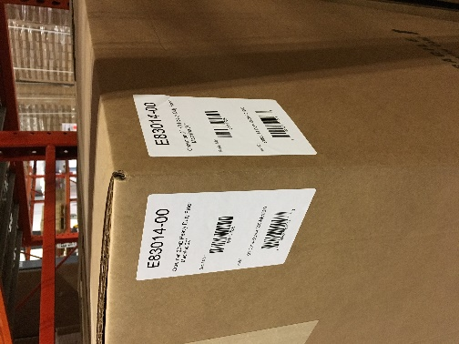

  - Place a “Do Not Top Load” label onto 2 opposite corners of the box. Also place a UN3529 (RLB065A) sticker to the front.

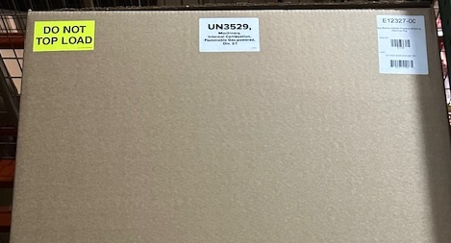
- References (optional section as needed)

- Training Guide

Functional Training Groups Requiring Training

- SOP Change Control

Date of Change | Reason for Change
Rev 01 - 11/18/2013 | This is the first version of the S.O.P. hence there are no revisions to this document.
Rev 02 - 1/18/2018 | Added Responsibilities Section and removed box cutting steps.
Rev 03 - 3/17/2025 | Updated steps, removed work center notes, added UN sticker

Approvals

Submitter/Author Approval:__________________________________ Date:______________________

Management Approval:______________________________________ Date:______________________

QAU Approval:_____________________________________________ Date:______________________

